**USER INTERFACE DESIGN**

Linta Maria Thomas

MCA LE

Roll No: 35

LOGIN

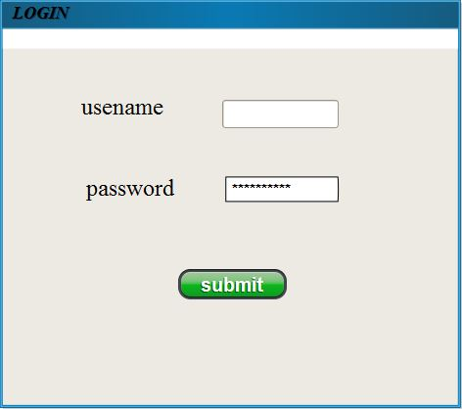

USER_REGISTRATION

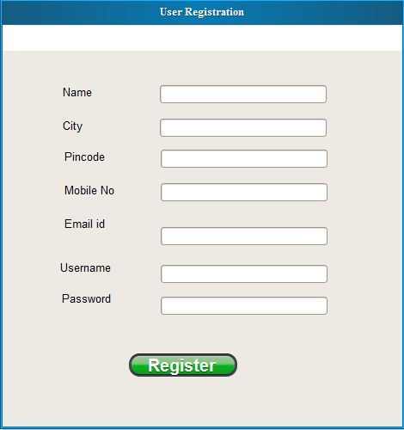

ORDER

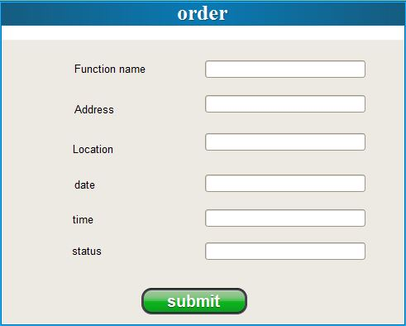

IMAGES

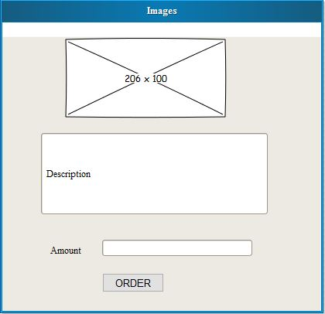

TRANSACTION

s

